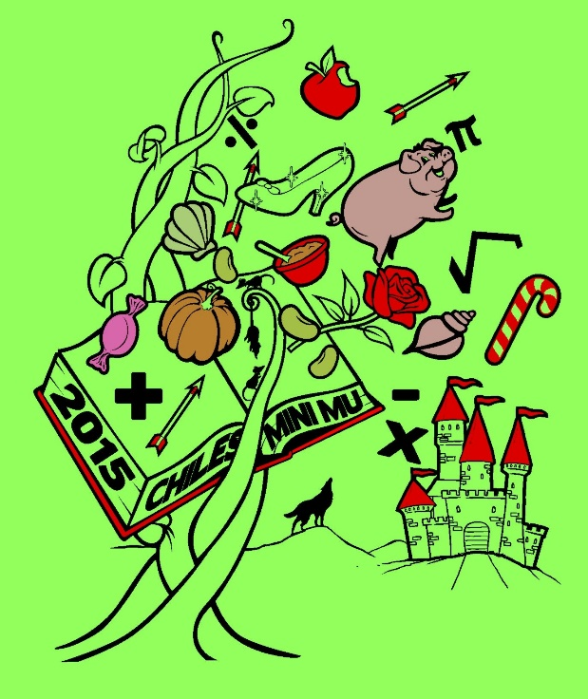

**2015**

**CHILES MINI MU**

**12 December 2015**

**Lawton Chiles High School**

**Hosted by Chiles Mu Alpha**

**Theta**

**PREALGEBRA**

**SESSION 2**

**RAPUNZEL**

Once upon a time, in a magical land, there lived a couple that desperately wanted a child….

You have 60 minutes to complete the following 30 multiple-choice questions. Choices A through D are answer choices for every problem. Choice E stands for “none of the above” or NOTA. Scoring is as follows: 5 points for a correct answer, 1 point if left unanswered, and 0 points for an incorrect response. Units are assumed. Figures are not necessarily drawn to scale. Have a ‘fairy’ good time!

